
INSTALLATION

Microsoft Dynamics Snap

How to Install Snap-ins

Installation Guide for
Time Management
Vacation Management
Business Data Lookup
Custom Report Generator
Customer Journal

Technical Pre-release Version 1.0 for Microsoft Dynamics TM AX 4.0 / 2007 Microsoft® Office system

February 22, 2007

Microsoft Dynamics Snap Sandbox

Table of Contents
INTRODUCTION 3
SYSTEM REQUIREMENTS 4
Pre-Requisites 4
INSTALLATION 5
REPAIR 6
UNINSTALL 7
LAUNCH THE SNAP 8

INTRODUCTION
Microsoft Dynamics Snap is an offering of applications that enable Information Workers to interact with Microsoft Dynamics information from within Microsoft Office applications.
The Phase 1 and 1.5 components of this program, which were made available in Feb 2006 and May 2006, worked with Microsoft Dynamics AX 3.0 data sources and other custom controls and assemblies created for Microsoft Office Professional 2003.
The Phase 2 showcases integration between Microsoft Dynamics AX 4.0 and the 2007 Microsoft Office system. Following is the list of snap-ins provided in Phase 2, which can be installed using this setup:
- Customer Journal Snap-in
- Custom Report Generator Snap-in
- Business Data Lookup Snap-in
- Vacation Management Snap-in
- Timesheet Management Snap-in

SYSTEM REQUIREMENTS

Pre-Requisites

Local System
- At least 5 MB of disk space must be available on the local machine installation location.
- The installation files, including setup.exe, must be copied on your local machine. Do not install from the download site or directly from a network share
- User should be the administrator of the local machine

2007 Microsoft Office System
- The 2007 Microsoft Office system should be installed, along with all the latest updates
- Microsoft Office Word, Microsoft Office Excel, Microsoft Office Outlook and Microsoft Office InfoPath should have been run at least once on the local machine
- Microsoft Office should be closed throughout the duration of setup

Microsoft Dynamics AX 4.0
- Microsoft Dynamics AX .NET Business Connector 4.0 must be installed
- The user must have permissions and access to the Microsoft Dynamics AX 4.0 server
- The user group should have full control over the BC proxy module

Framework and Runtime
- Microsoft .NET Framework 2.0 should be installed on the system
- Microsoft VSTO 2005 SE Runtime should be installed on the system

Miscellaneous
- Pre-release versions of all snap-ins should be uninstalled before starting installation
- The snap-ins have been tested on Windows Vista Enterprise, Windows XP Professional, Windows Server 2003 editions of Windows.
- The snap-ins have been tested on Enterprise and Standard editions of 2007 Microsoft Office system.

INSTALLATION

Microsoft Dynamics Snap can be downloaded directly from the Microsoft Dynamics Snap site and needs to be saved to a local machine for installation at a later time.
The following procedure will install a Microsoft Dynamics Snap application on the local machine:
- Close all Microsoft Office applications
- Run AXWave2Setup.exe
- The License Agreement dialog box appears, click ‘I accept this license agreement’
- A dialog box will appear asking for scenarios to install. Select the snap-ins you wish to install
- In the subsequent dialog box enter the name of the AX Server and click OK
- Type the location where you want to save this snap-in. The location can be retrieved by clicking on the Browse button. Once this step is completed, click Next
- The ‘Ready to Install’ dialog box appear, click Install
- The chosen snap-ins will be installed
- Once the installation is complete the ‘Installation Complete’ dialog box appears. Click Close
- Run GiveTrusttoSnapVSTO.cmd
[For Vista, run the above command in administrator mode]
- Open Microsoft Office applications

REPAIR

The following procedure will repair Microsoft Dynamics Snap-ins:
- Run AXWave2Setup.exe
- Select Repair, and click Next
-- OR --
- On the Start menu, click Control Panel, and then click Add or Remove Programs.
- Select Microsoft Dynamics Snap for Microsoft Dynamics AX 4.0 and then click Change
The Microsoft Dynamics Snap-ins for Microsoft Dynamics AX Setup window will open
- Select Repair, and click Next

This will begin the repair of the Microsoft Dynamics Snap-ins.

UNINSTALL

The following procedure will uninstall Microsoft Dynamics Snap-ins.
- Run AXWave2Setup.exe
- Select Uninstall, and click Next
-- OR –
- On the Start menu, click Control Panel, and then click Add or Remove Programs.
- Select Microsoft Dynamics Snap-ins for Microsoft Dynamics AX and then click Remove
- Select Uninstall, and click Next
This will remove all the program files and services but will not remove any dependent components installed during setup or any Microsoft Dynamics AX data stored in Microsoft SQL Server and Microsoft Active® Directory.

LAUNCH THE SNAP

To launch the snaps
1. Open Microsoft Outlook, Word, Excel and click on the Snap menu bar. The Business Data Lookup for AX 4.0 section will be visible in the Snap ribbon. The Timesheet Management and Vacation Management Snap’s will be visible in the toolbar.
2. Open Financial Dashboard and Budget Creator.xlsx workbook in the Example Reports folder installed along with the Snap. The CRG for AX 4.0 section will be visible in the Snap ribbon.
[Default Installation Path would be Program Files/Microsoft Dynamics Snap/AX 4.0/ Custom Report Generator/Example Reports/ ]
3. Open Customer Journal Form Template for AX.xsn in the install directory/Customer Journal
Note
If add-in is not appearing after installing, you will need to enable the Microsoft Dynamics Snap add-ins. Follow the steps given below to do this.
1. Click Customize Quick Access Toolbar
2. Choose More Commands …
3. Go to the Add-Ins menu, select COM add-ins in the Manage drop down and click Go.
4. Check the checkboxes next to the Microsoft Dynamics Snap Add-ins. Click Ok and restart Office application.

If the Infopath form shows an error on opening, close the form and follow the steps below.
1. Go to Add-Remove Programs, and click Change against Microsoft Office 2007.
2. The maintenance screen will be launched.
3. Select Add- Remove features and click continue.
4. In the Installations Options tab, click arrow beside Microsoft Office InfoPath, and select Run all from My Computer, and click Continue.
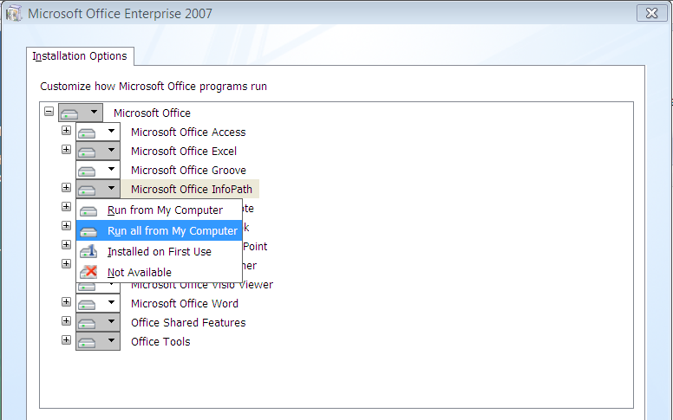

Microsoft Dynamics is a line of integrated, adaptable business management solutions that enables you and your people to make business decisions with greater confidence. Microsoft Dynamics works like and with familiar Microsoft software, automating and streamlining financial, customer relationship and supply chain processes in a way that helps you drive business success.

U.S. and Canada Toll Free 1-888-477-7989
Worldwide +1-701-281-6500
www.microsoft.com/dynamics

The information contained in this document represents the current view of Microsoft Corporation on the issues discussed as of the date of publication. Because Microsoft must respond to changing market conditions, this document should not be interpreted to be a commitment on the part of Microsoft, and Microsoft cannot guarantee the accuracy of any information presented after the date of publication.
This White Paper is for informational purposes only. MICROSOFT MAKES NO WARRANTIES, EXPRESS, IMPLIED, OR STATUTORY, AS TO THE INFORMATION IN THIS DOCUMENT.
Complying with all applicable copyright laws is the responsibility of the user. Without limiting the rights under copyright, no part of this document may be reproduced, stored in or introduced into a retrieval system, or transmitted in any form or by any means (electronic, mechanical, photocopying, recording, or otherwise), or for any purpose, without the express written permission of Microsoft Corporation.
Microsoft may have patents, patent applications, trademarks, copyrights, or other intellectual property rights covering subject matter in this document. Except as expressly provided in any written license agreement from Microsoft, the furnishing of this document does not give you any license to these patents, trademarks, copyrights, or other intellectual property.

© 2006 Microsoft Corporation. All rights reserved.
Microsoft, the Microsoft Dynamics Logo, 2007 Microsoft Office System, BizTalk, Dexterity, FRx, Microsoft Dynamics, SharePoint, Visual Basic, Visual C++, Visual SourceSafe, Visual Studio, Windows, and Windows Server are either registered trademarks or trademarks of Microsoft Corporation, FRx Software Corporation, or Microsoft Business Solutions ApS in the United States and/or other countries. Microsoft Business Solutions ApS and FRx Software Corporation are subsidiaries of Microsoft Corporation.

